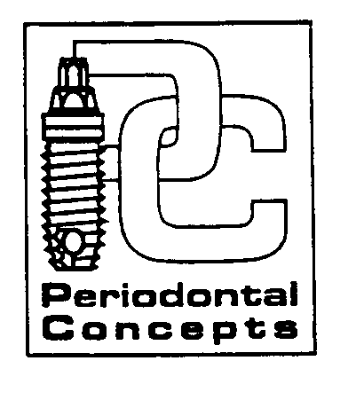
INSTRUCTIONS FOLLOWING PERIODONTAL SURGERY
General Osseous Surgery – Bone Grafts – Implants

We care about you and the success of your surgery. For optimal comfort and healing your utmost in post-surgical cooperation is required.

BLEEDING: You may expect minor oozing for up to 24 hours after surgery. If bleeding continues, apply pressure in the area with damp gauze for 30 minutes. You may also apply a warm tea bag, as the tannic acid may help stop the bleeding. If heavy bleeding persists, contact us immediately.

SWELLING: Swelling is normal following periodontal surgery. As soon as possible, place an ice pack on the outside of your cheek adjacent to the surgical site, using the pack 15 minutes on and 15 minutes off. Continue icing for the first 24-36 hours. If you experience swelling after 36 hours, switch to warm packs to increase circulation.

MEDICATIONS: Take your prescriptions as instructed. Take medications with food to lower the chance of nausea. Avoid alcohol and do not operate heavy equipment or motor vehicles while taking prescription pain medications. To best control post-operative discomfort, take pain medication before the numbness wears off. If you become sick, or a rash develops, contact us immediately. Women on birth control pills should use alternative contraception while taking antibiotics.

FLUIDS: Drink plenty of fluids for the next few days. Avoid using a straw for the first 72 hours following surgery. Suction forces in the mouth encourage bleeding.

DIET: Eat nourishing foods that are soft and cool for the first 24-48 hours. Examples include blended fruits and vegetables, cottage cheese, instant breakfast, applesauce, yogurt, etc. Do not chew in the area of the procedure for the first two weeks. Avoid gum and hard, sticky or small seed foods that could traumatize and injure the surgical site.

ACTIVITY: Rest is essential for successful recovery. Please rest the day of your procedure and reduce your activities for the next few days. Avoid running or strenuous activity for 3-4 days.

HOMECARE: WEEK ONE: Gently rinse your mouth with warm salt water (1/4 tsp. to 8 oz. water) after each meal. Use the prescribed rinse morning and night, gently swabbing the surgical site and sutures. Avoid any vigorous rinsing for the first 48 hours.
WEEK TWO: Continue warm salt water rinses. Clean the surgical site by dipping a cotton swab into the prescribed rinse and gently massage the area. Do not brush the surgical site until instructed.

SUCCESS: No smoking (or tobacco products), peroxide or commercial mouth rinses for at least 10 days.

SUTURE/DRESSING: If stitches or periodontal dressing were placed we will remove them at your post-op visit in approximately 2 weeks. It is normal for sutures or dressing to become loose. We will advise you on how to care for the area at this appointment.

If you have any questions regarding your surgical procedure, please, do not hesitate to contact our office.

Cascade Park (360) 254-8151
Emergency: Dr. Derhalli (360) 241-3664

